SkillSwap Hub - Final Task Internship Report
Project Title: SkillSwap Hub
Submitted by : Rubab Fatima
Technology Stack: Flask, MongoDB, Bootstrap, JavaScript
Github link : https://github.com//RubabFatima232

1. Abstract
SkillSwap Hub is a full-stack web application that allows users to share, learn, and manage skills. It is built using Flask and MongoDB with a responsive frontend using Bootstrap.

2. Introduction
This project provides a platform for users to exchange skills and interact with others through a web-based system.

3. Objectives
- Build a skill sharing platform
- Implement CRUD operations
- Provide secure authentication
- Enable search and filtering
- Design responsive UI

4. Technologies Used
Frontend: HTML, CSS, Bootstrap, JavaScript
Backend: Flask (Python)
Database: MongoDB
Other: Jinja2, Werkzeug

Flow:
User → Frontend → Flask Server → Database (MongoDB) → Response → UI

5. System Modules
Authentication Module
Dashboard Module
Skill Management Module (CRUD)
Search Module
API Module

6. Database Design
Users Collection: name, email, password, created_at
Skills Collection: title, description, category, user_id, created_at, updated_at

7. Authentication Module
The authentication system allows users to securely register and log in.

Features:
- User registration
- Password hashing (Werkzeug)
- Session-based login
- Secure logout system

Screenshot Placeholder:
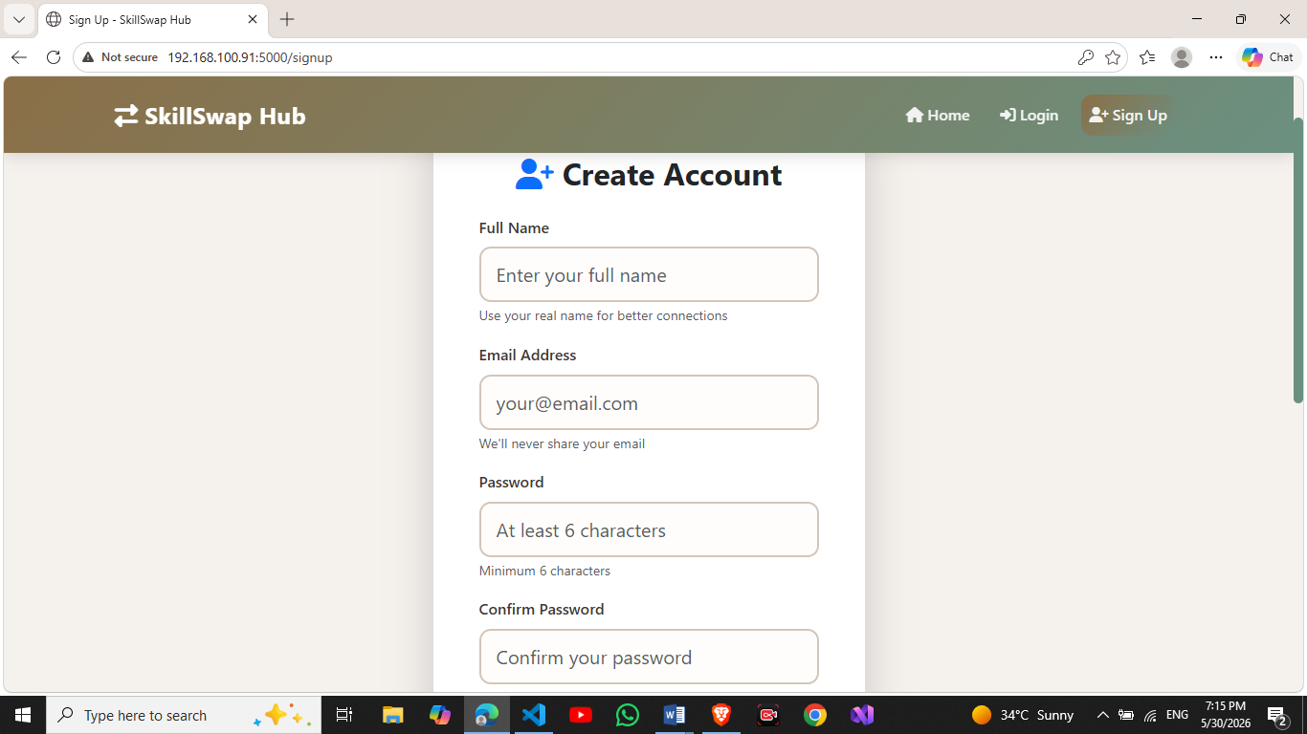

8. Home Page Module
The home page is the landing interface of the system.

Features:
- Hero section with dynamic buttons
- Platform statistics
- Featured skills display
- Call-to-action section

Screenshot Placeholder:
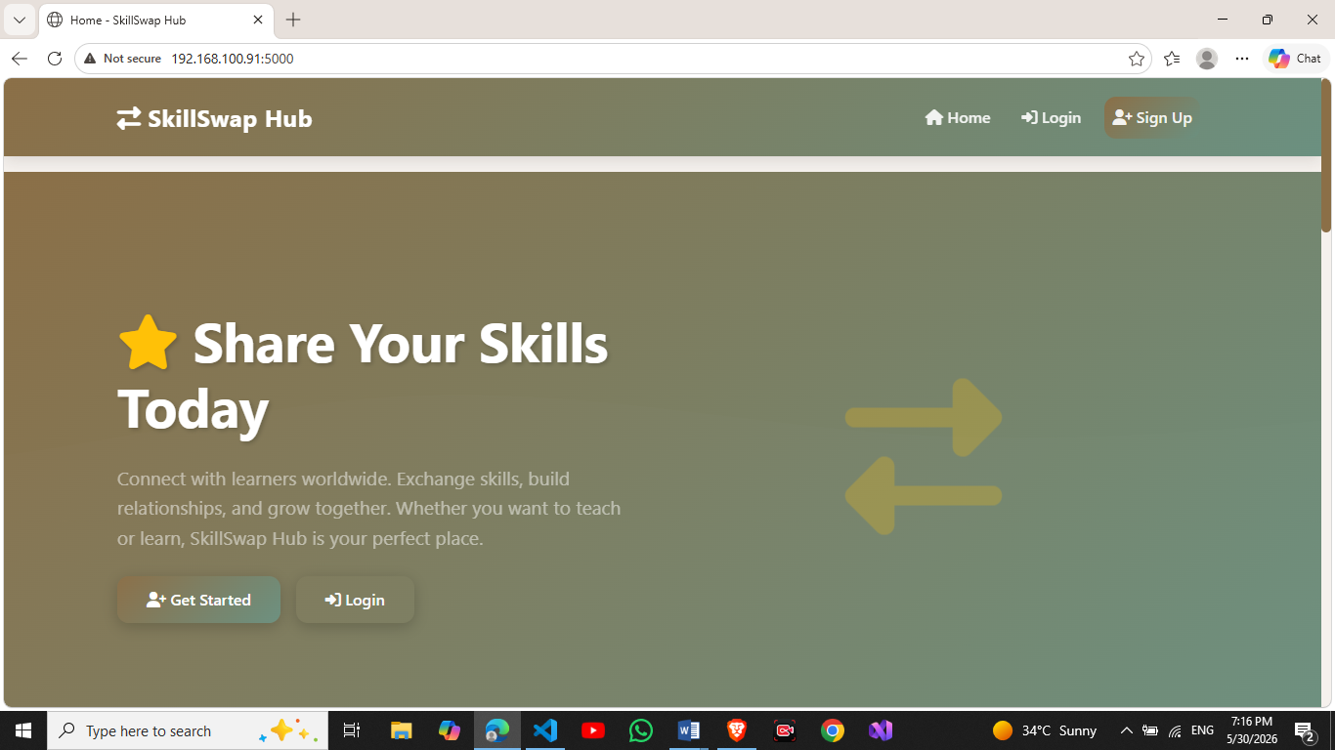

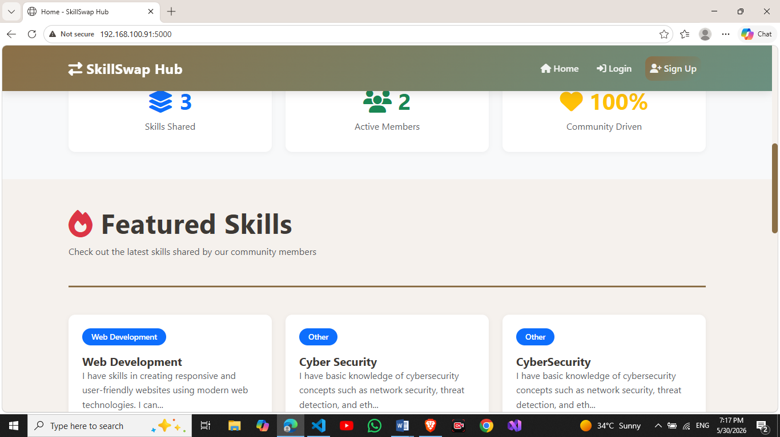

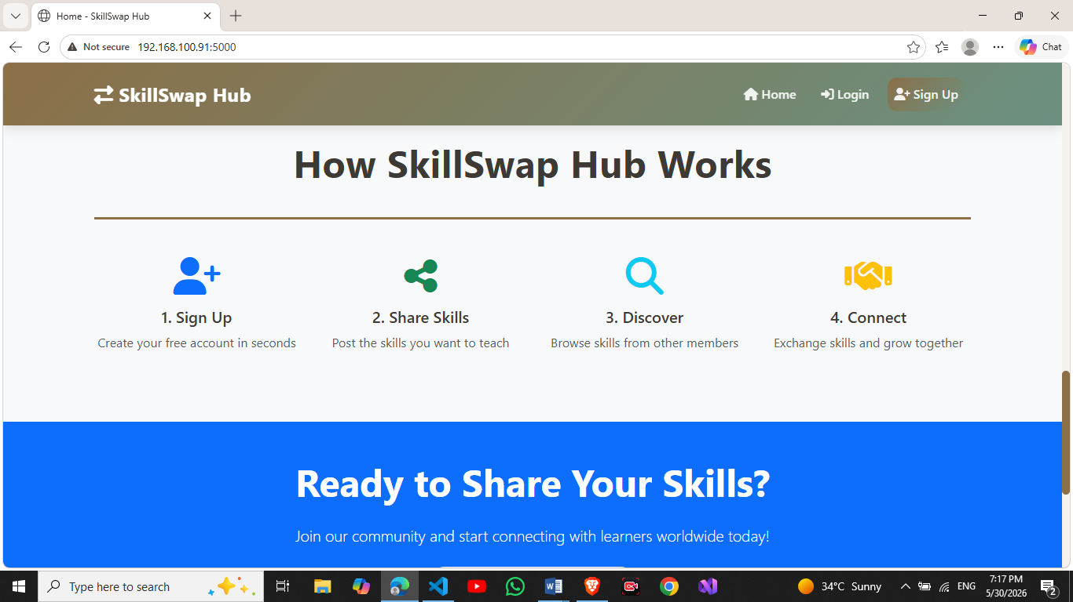

9. Dashboard Module
The dashboard allows users to manage their skills.

Features:
- View personal skills
- Edit and delete skills
- View statistics
- Quick actions panel

Screenshot Placeholder:
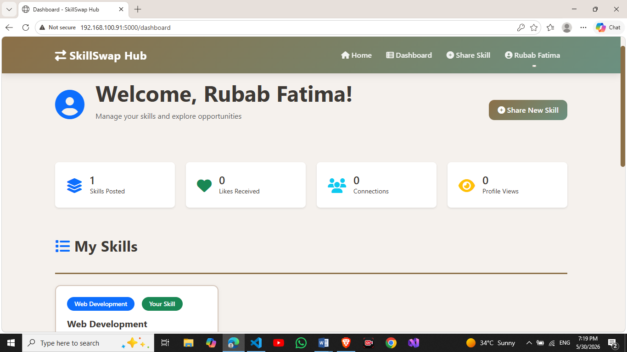

10. Skill Management Module (CRUD)

Create:
Users can post new skills.

Read:
Skills are displayed dynamically.

Update:
Users can edit existing skills.

Delete:
Users can remove skills.

Screenshot Placeholder:
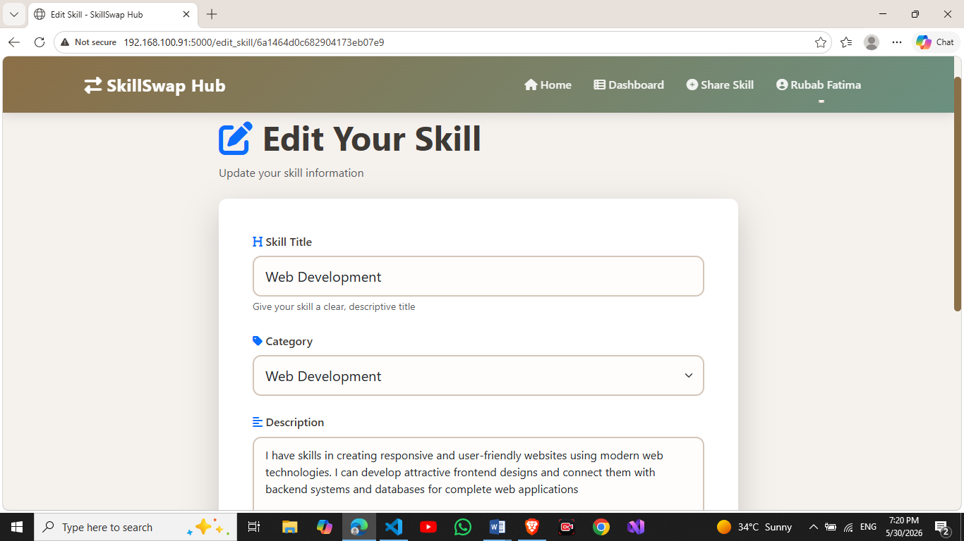

11. Search Module

Features:
- Search by title
- Filter by category
- Case-insensitive search using regex

Screenshot Placeholder:
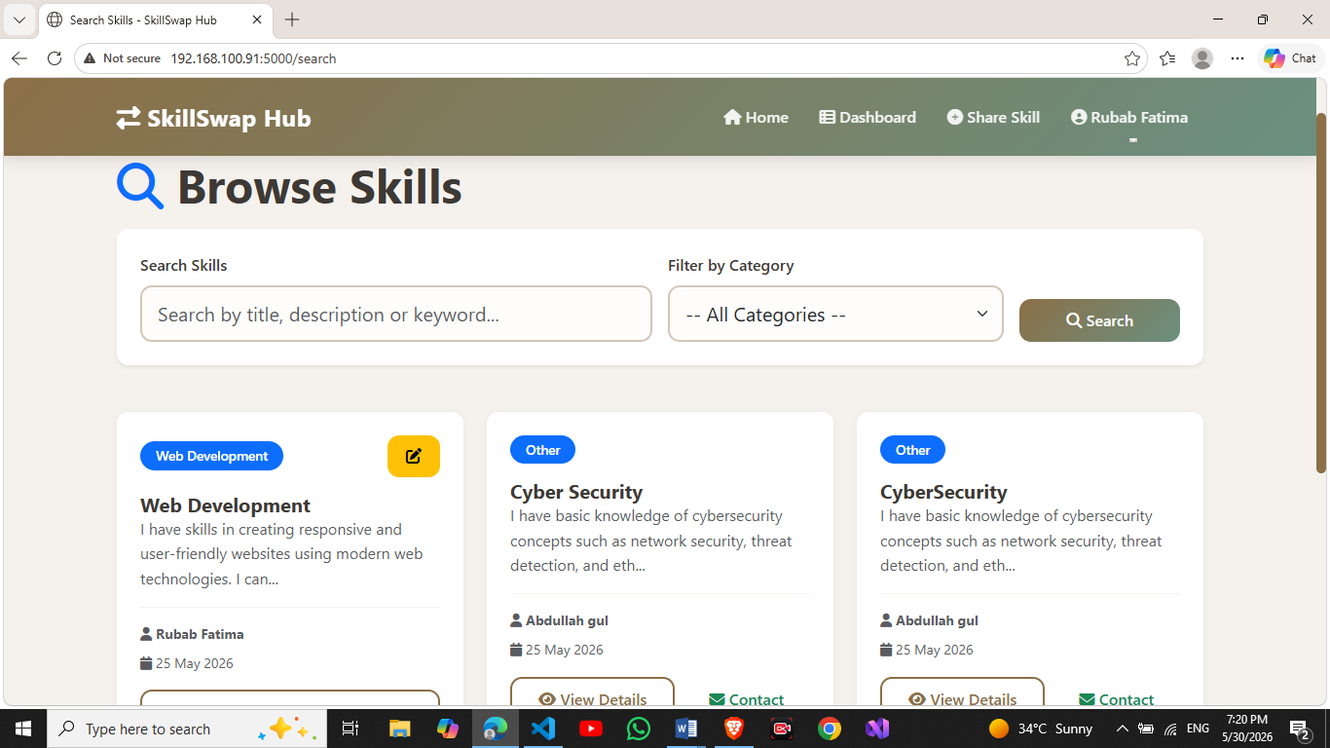

12. API Module

Endpoint:
GET /api/skills

Function:
Returns all skills in JSON format.

13. System Features
User registration and login
Create, update, delete skills
Search and filter skills
Responsive UI
Session management

14. Conclusion
The SkillSwap Hub project successfully demonstrates a full-stack web application with complete functionality for skill sharing and management.

